Click or tap here to enter text.

Click or tap here to enter text.

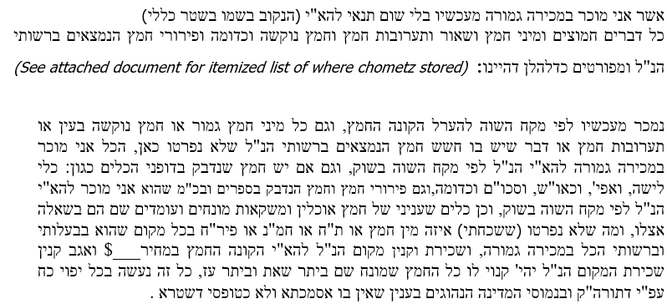

Click or tap here to enter text.

Sign: Click or tap here to enter text.